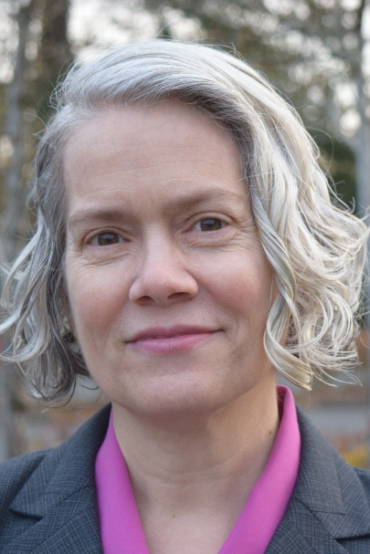
Cynthia Good, LMHC, RH, IBCLC, PMH-C

Cynthia Good, LMHC, RH, IBCLC, PMH-C is an integrative psychotherapist, consultant, supervisor, author, and trainer based in Washington state. She is an ESTI/ESTNA Certified Ego State Therapy Consultant, an EMDRIA Approved Consultant, ESTNA/ESTI-approved EST Training Assistant, and PMH-C Certified Perinatal Mental Health Professional. She also holds ASCH Certification in Clinical Hypnosis. She specializes in the integrative treatment of complex trauma and dissociation, as well as mental health challenges during the reproductive, perinatal, and early parenting time period, including healing from domestic violence and narcissistic abuse and parenting while experiencing social injustice. Her blog, On the One Hand, explores issues and resources related to the experience and integrative treatment of complex trauma and other mental health challenges.

Cynthia is the author of the invited chapter "Principle-Based Integration of EMDR, Ego State Therapy, and Clinical Hypnosis in the Perinatal Time Period" in "EMDR for Reproductive, Perinatal, and Infant Mental Health", edited by Mara Tesler Stein (Springer, in press). She is also a co-author of the chapter “Was sind Ego-States eigentlich genau? – Historischer Hintergrund, Entwicklung und Zukunftsperspektiven” (“What Exactly are Ego States? – Historical Background, Development and Future Perspectives”) in “Ego-State-Therapie: Von den historischen Wurzeln zur innovativen Praxis” (Ego-State Therapy: From Historical Roots to Innovative Practice), edited by Woltemade Hartman (Carl-Auer, in press). Cynthia serves on the advisory committee for Ego State Therapy North America (ESTNA) and as an EST Training Assistant to Wendy Lemke and Woltemade Hartman for both foundational and advanced EST training. In addition, since 1995, she has presented over 100 times at in-person and online conferences. workshops, seminars, and other events in the US and internationally, serving as a plenary and keynote speaker many times. She formerly served as Adjunct Professor in the Department of Midwifery at Bastyr University in Washington state, where she taught counseling skills, and at Parkland College where she taught psychology and statistics courses. She has decades of experience providing training related to psychology, lactation, parenting, and culture to mental health care providers, health care providers, organizations, and individuals.

